H-1B Sponsorship Request Process in Terra Dotta

Hosting departments will need to identify the contact person in the department that has responsibility for coordinating sponsorship requests through ISO or HR/Immigration Services. The departmental administrative contact will have login permission to our on-line scholar/employee management portal. If your department does not have a contact person or you do not know who that person is, please contact the ISO or HR/Immigration Services directly.
Step 1:
To access the scholar/employee portal: https://connect.issp.virginia.edu/
Click on the link labeled Scholar/Employee & Department Portal
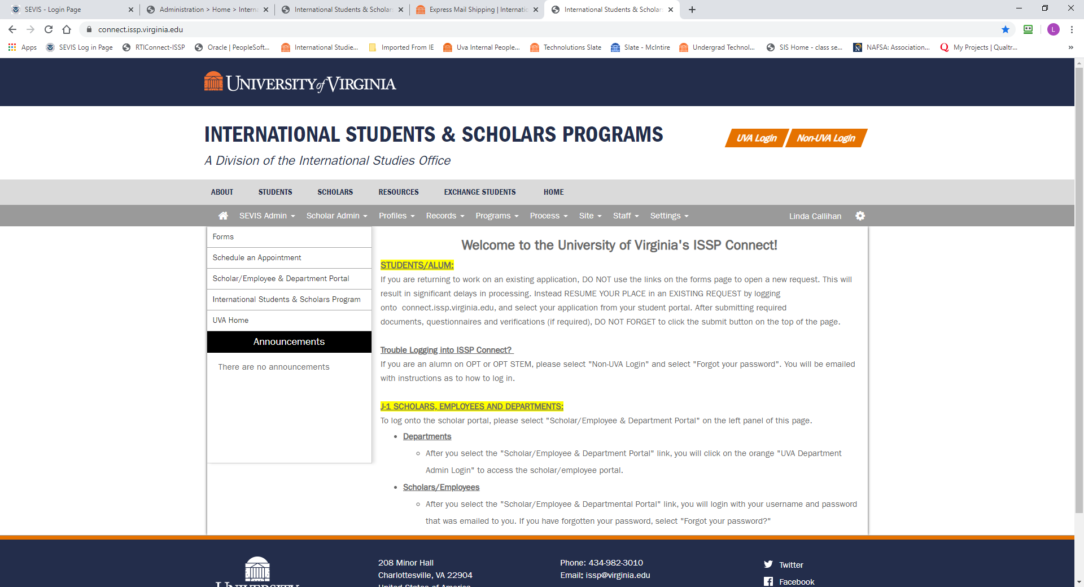

At the Log In Screen click on the UVA Department Admin Login in the orange bar. This will take you to your Netbadge login and to your department’s portal.
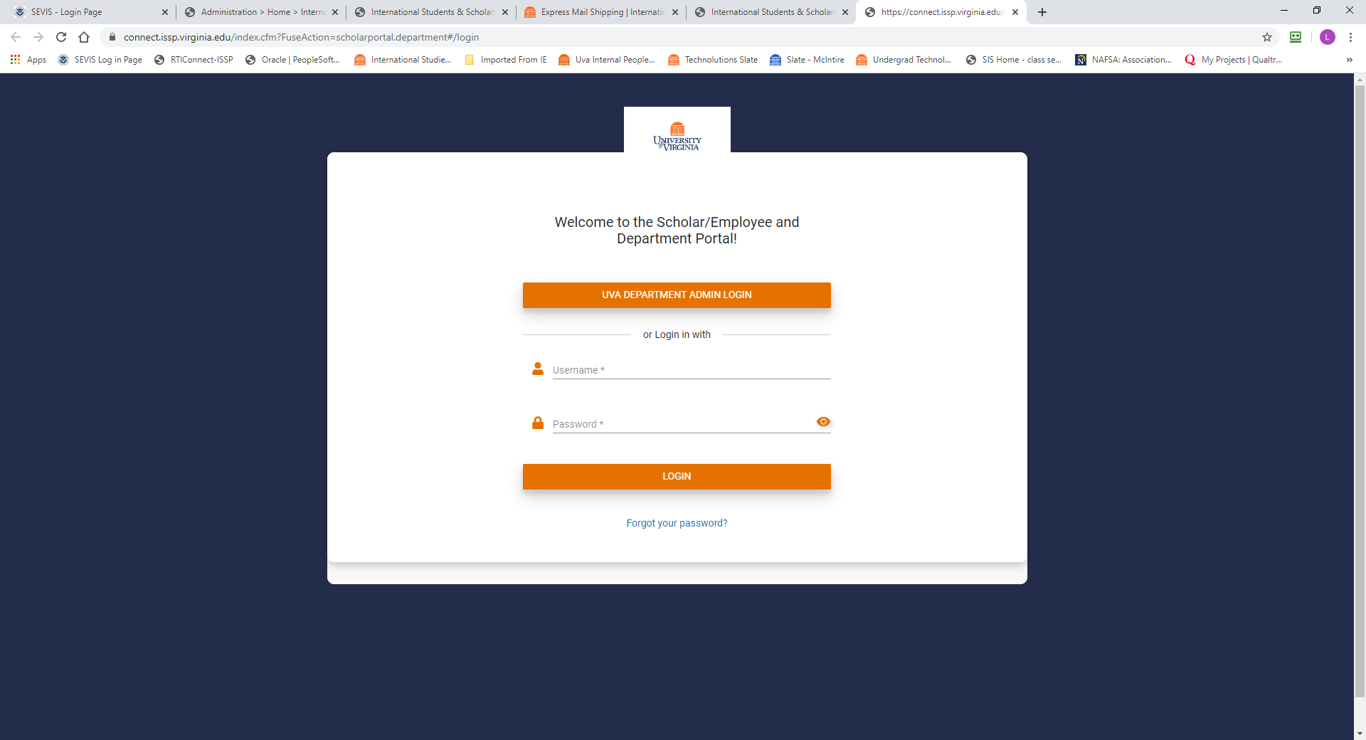

You should be able to see the profiles for scholars/employees that are sponsored with both H-1B and J-1 for your department. You should also be able to see the contact details for the department administrators that have access to your department portal.
Step 2:
To begin a request click on the New Sponsorship Request button. Complete the information requested on the screen including the visa type that you are requesting (either H-1B or J-1) and submit the request. UVA Immigration offices will review and confirm the appropriate visa type.
Step 3:
The department contact will receive a notification when the confirmation of visa type has been approved by HR Immigration Services. The scholar/employee will appear in your dashboard as a pending request. Additional information screens to be completed will appear in the scholar/employee profile on your dashboard. Each information screen includes specific instructions for completing the screen as well as any documents that are required to be uploaded to the application.
At this point in the process, the department contact can invite the employee to access their portal to confirm personal information and upload any required documents including passport copy, CV or resume, immigration history, and educational background. The department contact can choose to gather all required information and upload everything before giving the scholar access if they prefer. To provide the employee with access, click “Invite Scholar” in the upper right of the display page.

Step 4:
Once the information has been completed, and required documents uploaded, the Department Admin should click the “Submit to ISSS” button in the upper right of the display page. This will notify Immigration Services that the submission is ready for review.

Step 5:
ISSP or HR/Immigration Services will review and process the request.

