
Accessing Merit Reports in Workday

- In Workday, navigate to the report called My Team's Compensation Base Pay Changes.
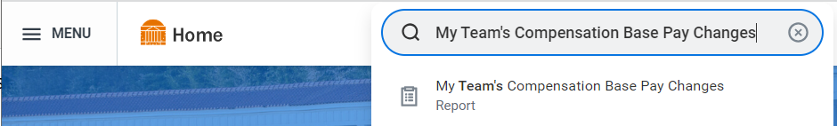
- Be sure to change the date to 9/13/2026 and check the box to only see your direct reports who are receiving a Merit (Annual Increase) Adjustment.
- Click OK to run the report.

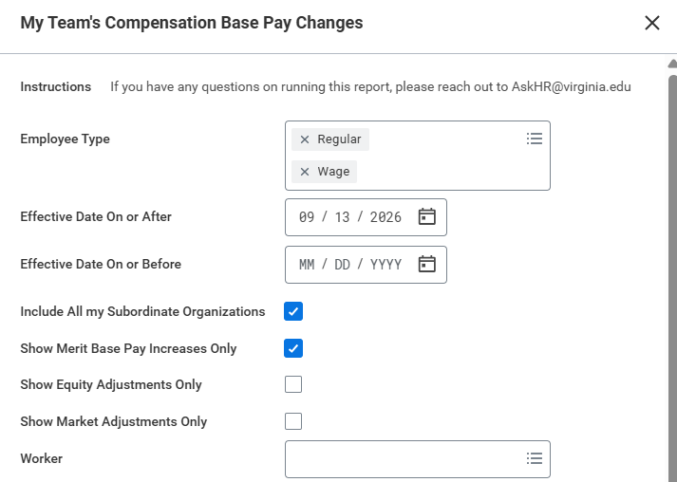
- In Workday, navigate to the report called Bonus and One Time Payment Information.
- Be sure to change the Scheduled Payment Date on or After to 9/13/2026 and change the plan to “Annual Merit Bonus” to see your direct reports who are receiving a Merit (Annual Increase) Bonus.
- Click OK to run the report.

