Guide to UVA
Student Employment
with
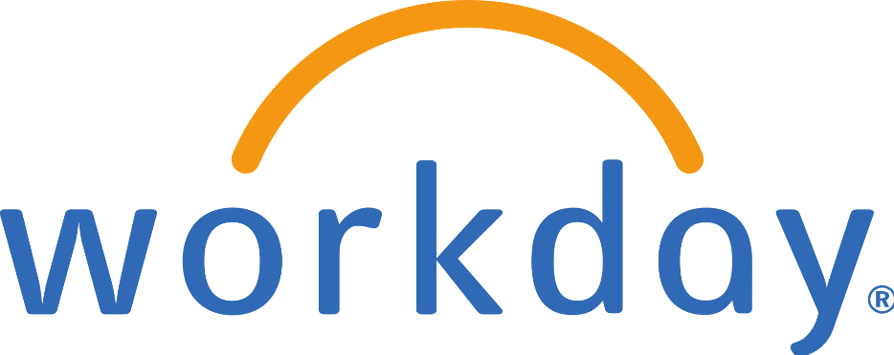

Table of Contents

Introduction 3
Twelve “Must Knows” for Hiring Student Employees 4
Student Employment Policies 6
Wage Authorization 6
Assistantship Policy 6
Background Screening 6
Federal Work-Study 6
Student Employment & Workday 7
Student Information System Integration 7
Student Employment Eligibility Rules 7
Mass Hires with Enterprise Interface Builder (EIB) 7
Roles & Security 8
Supervisory Organizations 8
Key Reports 8
“Student Workers” Job Family and Job Profiles 9
Student Job Profile Selection Guide 10
Job Aids for Hiring Students in Workday 11
Hourly Student Hiring 11
Period Activity Pay Student Hiring 14
Create Job Requisition 21
Managing Multiple Jobs: Add Job, Switch Primary Job, End Additional Job, Terminate 21
Additional Job Aids to Review 22
Additional Resources 23

Introduction
Student employment is an essential element of the University’s mission and operations. Each year, approximately 5,000 students work in over 7,000 on-Grounds positions, some supporting UVA’s education and research programs as part of their academic training, others earning valuable employment experience while supporting University operations.
With the launch of Workday, we have an opportunity to make many elements of managing student employment easier than ever before. However, Workday is just one piece of a complex puzzle that requires the cooperation of many units across grounds and a solid understanding of a variety of policies and procedures. So, while this guide is primarily intended as a storehouse of information related to student employment in Workday, where possible additional contextual information has been interwoven to assist in making the student employment experience as efficient and policy-compliant as possible.
Note: Some units may have unit-specific student employment policies in addition to the University-wide information provided here. Please ensure that you also adhere to any area-specific student employment policies in place.

Twelve “Must Knows” for Hiring Student Employees
While there are many processes and policies governing student employment, the following 12 items are essential when employing students at UVA:
- Federal law requires all new employees to complete the Form I-9, with part I completed by the employee by the first day of employment and part II completed by the employer within three days of hire. To ensure we are compliant with this requirement, always enter a student’s effective date as the actual first date of work, rather than an earlier date. Entering an earlier date makes it more likely that we appear out of compliance with this requirement, when in fact the student has not yet begun work. Once the hire is complete, students will receive a Workday inbox task to complete part I. Until the I-9 is complete, they will not receive the Payment Elections task to add direct deposit information.
- Students must be enrolled full-time to be eligible for student employment (exceptions are detailed in the Wage Authorization).
- Students cannot work more than 20 hours per week in all jobs during any session in which they are enrolled, excluding breaks (exceptions are detailed in the Wage Authorization). Students on F-1 and J-1 visas cannot work more than 20 hours per week wile school is officially in session (no exceptions).
- Student employees who will have contact with patients or minors must undergo additional background screening as explained in HRM-034: Background Checks and Ongoing Responsibility for Employees to Disclose Criminal Convictions.
- Student employees may continue to work in a student employment position after Spring graduation until the first day of the Fall semester on an exception basis. Such exceptions are only allowable for wage assignments that begin at least 30 days prior to the end of the spring term. Students graduating at the end of the fall semester cannot continue working as a student into the January term/Spring semester. Please see additional related information in the Wage Authorization.
- Student employees are generally exempt from FICA taxes while enrolled at least half-time (eligibility requirements are detailed in HRM-008: Student FICA Tax Exemption).
- If students have been offered a Federal Work-Study (FWS) award, it is in a hiring unit’s best interest to employ the student in a FWS position as the program may fund 75% (or in the case of America Reads, 100%) of the student’s wages; however, this requires additional steps prior to hire, so ensure you follow all guidelines in Student Financial Services’ FWS Employer Handbook prior to initiating a hire in Workday.
- Student job requisitions and hires must be initiated under the manager’s Job Management “JM” Supervisory org. If you do not have a JM supervisory org., please contact your HR Business Partner to have one created.
- In Workday, all managers and individuals with the Student Hiring Support role have the ability to access the Find External Students report in Workday that indexes all active students, check a student’s eligibility for student employment and initiate the Hire Student task. Managers can initiate Create Job Requisition to request a job posting to identify an ideal candidate for a student position. Individuals with Student Hiring Support cannot initiate Create Job Requisition in Workday.
- Altering the title field on the “Hire Student” task in Workday allows managers or those with the Student Hiring Support role to customize a student employee’s job title, which will populate on a student’s timecard—essential for students with multiple jobs.
- Students (and all non-exempt employees) can enter hours in Workday retroactively for 30 days after the end of a payroll period; if 30 days have passed, a paper timecard must be submitted to askhr@virginia.edu for processing.
- Student employees are not eligible for the UVA Health Plan (for employees). Eligibility for the Student Health Plan is entirely separate from a student’s employment relationship with UVA; however, graduate students with assistantships may be eligible for health plan subsidies (more information about graduate assistantships can be found in PROV-001: Graduate Assistantships).

Student Employment Policies
Student employment is governed by a number of intersecting policies. Exactly which of the policies below affects an individual student employee is dependent upon the type of position in which they work and the nature of that work.

Wage Authorization – This document is updated annually.
Policy: http://provost.virginia.edu/wage-authorization
Applies to: All student wage employees
Summary: This foundational policy covering all student wage employment defines student employment eligibility rules, hour limits (and the exception process for this rule), compensation ranges, the employment of international students, and more.

Assistantship Policy
Policy: http://uvapolicy.virginia.edu/policy/PROV-001
Applies to: Graduate students with assistantships (GTAS/GRAs)
Summary: This policy covers all aspects of graduate assistantships, including types of assistantships, qualifications, supervisory responsibilities, appointment restrictions, tuition remission and adjustment, and health insurance subsidies.

Background Screening
Policy: https://uvapolicy.virginia.edu/policy/HRM-034
Applies to: Student employees who have contact with patients or minors
Summary: This University-wide background check policy indicates that while in general student employees are not subject to a background check prior to employment, any student employee who has contact with patients or minors must undergo additional background screening processes.

Federal Work-Study – The FWS Employer Handbook is updated annually.
Procedures: http://sfs.virginia.edu/internal/fwsadmin
Applies to: Student employees supported with Federal Work-Study funding.
Summary: Federal Work-Study (FWS) is a federal program that supports part-time employment opportunities for students with demonstrated financial need. At UVA, student wages are subsidized at 75% from federal funds, and the remaining 25% is paid by the student’s hiring department or approved off-grounds employer. The FWS program is administered by Student Financial Services at UVA, and the Employer Handbook linked above provides a comprehensive resource for hiring units that details hiring policies, compensation ranges, and instructions regarding Labor Distribution. Because additional requirements must be met prior to hiring a student funded through the FWS program, ensure you have reviewed all information in the FWS Employer Handbook prior to initiating an FWS hire in Workday.

Student Employment & Workday
Workday offers a number of key features that streamline the student hiring process. In the next section, you will find step-by-step job aids for all student-specific processes; however, knowing how and why those processes work requires an understanding of a number of foundational Workday features and UVA-specific configurations that drive student employment, which are described below.

Student Information System Integration
The foundation for all student employment in Workday is a daily integration that runs from the Student Information System to Workday. This file populates a basic student object for all active students and includes demographic, enrollment, student employment eligibility, and Federal Work-Study eligibility information. These basic student objects allow users with appropriate security to search for students, check their eligibility for specific jobs, and initiate hiring without entering any demographic information. After hire, the integration also allows these individuals to re-verify in real-time that employed students remain eligible for their student employment positions.

Student Employment Eligibility Rules
Student Employment Eligibility Rules have been configured in Workday to ensure that individuals responsible for hiring student employees can pre-verify that students are eligible for specific jobs and also re-verify that students are eligible for their current jobs any time after hire. Two types of rules have been configured: critical and non-critical. Critical rules prevent a student from being hired if conditions are not met, while non-critical rules providing an alert but allow the process to condition. Currently, only Federal Work-Study eligibility is a critical rule (a student who is not FWS eligible cannot be hired into a FWS job profile). Non-critical rules include:
- A student must be enrolled full-time to be eligible for student employment
- A student’s level (undergraduate or graduate) must match the selected job profile to ensure compensation ranges are appropriate
These non-critical rules do not stop the hiring process to allow, for example, a student who has not yet enrolled full-time, but who intends to, to be hired while they complete their enrollment. After hire, the Ineligible Student Employees report can be run at any time to verify that a currently employed student is eligible for their job based on both critical and non-critical rules. Any student hired who was ineligible at time of hire should have their eligibility verified using this report as soon as they begin work.

Mass Hires with Enterprise Interface Builder (EIB)
For areas with high volumes of student hiring that occur at one time, Workday can facilitate a mass upload of information to initiate individual Hire Student tasks. Significant technical preparation and functional data gathering, and validation are required to use this process, so this can only be used for truly high-volume mass hiring events. If you think this may be relevant to your area, please contact your HR Business Partner to initiate a request.

Roles & Security
The responsibility for initiating student hires in Workday rests with two security roles:
- Manager (or their delegate)
- Individuals provisioned with the Student Hiring Support role in Workday.
Both groups have access to the Find External Students report, all basic student object data, and all tasks related to hiring students (including Hire Student, Pre-Verify Student Employment Eligibility, Add Additional Job, and Request Compensation Change. This provides access to the Ineligible Student Employees report. Student Hiring Support role cannot initiate Create Job Requisition.
Individual who are not managers (or their delegates) or Student Hiring Support will not be able to initiate student hiring-related tasks in Workday, nor will they have access to data in the student employee-related reports described in this guide.

Supervisory Organizations
Supervisory Organizations are Workday’s primary means of organizing people. Supervisory organizations function much like departments did in our legacy systems; however, anyone who supervises one or more people at UVA has at least one of their own supervisory organizations.
For student employment, the key feature of supervisory organizations to know is that there are two types:
- Position Management (used for regular, benefitted employees)
- Job Management (used for students, wage, temp employees, and non-paid “contingent workers”)
Students should always be employed in job management supervisory organizations, which are noted with “JM” in their titles. Using a “JM” supervisory organizations means you do not need to create a permanent position in the organization to be able to hire the student.
When initiating a student hire in Workday, if you do not a see a supervisory organization for the intended manager that indicates “JM,” you will need to contact your HR Business Partner to request that one is created.

Key Reports
- Find External Students: Indexes all active student with basic student objects in Workday built through the Student Information System/Workday integration. Managers and Student Supporting Support can search for students and/or filter based on academic unit, class level, Federal-Work Study eligibility, and more. If the intended student is identified through the report, the Pre-Verify Student Employment Eligibility and Hire Student tasks can be initiated directly from the report.
- Ineligible Student Employees: After selecting a Supervisory Organization, this report returns the names of any students employed by that Supervisory Organization who is no longer eligible for their position based on critical and non-critical student employment eligibility rules. The report also indicates the reason the student is not eligible. If a student is no longer eligible, their student job should be terminated, or if desired, an additional job should be added (e.g., one that is not a FWS job or one that is a Temporary job) and the other ended.

“Student Workers” Job Family and Job Profiles
In Workday, we now have a dedicated job family for student employees. This job family, labeled “Student Workers,” is visible throughout Workday whenever you are selecting a job profile and searching using the “By Category” options. Within this job family are three groups:
- Graduate Teaching/Research Assistants
- Undergraduate/Graduate Wage
- Work Study
Student employees should always be employed in one of the job profiles contained within the “Student Workers” job family. Below, you will find a guide to the student job profiles available in Workday and a summary of their intended use. It is essential that the correct job profile is selected as student employment eligibility (particularly related to Federal Work-Study) and compensation (e.g., hourly wage vs. period activity pay) is tied to the job profile selected.
Note: Because the Job Title field can be used to customize a student’s job title (and the Job Title shows up on the timecard), the guide below indicates the use of a limited number of generic job profiles and the utilization of the Job Title field for “working title”-like customization. Many more specific job profiles were converted from our legacy system into Workday because they had incumbents at the time of conversion, but our advice is to discontinue their use going forward to streamline eligibility rules and improve consistency.

Student Job Profile Selection Guide

Job Profile | Pay | Intended Use
Undergraduate/Graduate Wage
J0277 – Undergraduate Student | Hourly | Undergraduate student employees not funded through FWS who will not have contact with minors or patients. Goes with code 89011.
J0141 - Undergraduate Student Worker (Contact Minor) | Hourly | Undergraduate student employee who will have contact with minors: contact UVAHR prior to hiring as a background check is required
J0140 - Undergraduate Student Worker (Patient Contact) | Hourly | Undergraduate student employee who will have contact with patients: contact UVAHR prior to hiring as a background check is required
J0462 – Undergraduate Research General | Hourly | Undergraduate student employee who conducts research under the direct supervision of a faculty member or research supervisor.
J0463 – Undergraduate Research Advanced | Hourly | Undergraduate student employee who conducts research under limited supervision of a faculty member or research supervisor. Requires some research training/experience.
J0280 - Graduate Student A | Hourly | Graduate student employees not funded through FWS or assistantships who will not have contact with minors or patients; most common graduate job profile (without an assistantship). Goes with code 89109.
J0139 - Graduate Student Worker (Contact Minor) | Hourly | Graduate student employee who will have contact with minors: contact UVAHR prior to hiring as a background check is required
J0138 - Graduate Student Worker (Patient Contact) | Hourly | Graduate student employee who will have contact with patients: contact UVAHR prior to hiring as a background check is required
J0313 - Student - Period Activity Pay | Period Activity Pay* | All student employees receiving Period Activity Pay rather than an hourly rate, besides GTAs/GRAs. Used in rare/unique circumstances. Please contact your HR Business Partner or email askhr@virginia.edu to discuss.
Federal Work-Study
J0142 - Federal Work Study Undergraduate A | Hourly | Refer to SFS’ FWS
J0143 - Federal Work Study Undergraduate B | Hourly | Refer to SFS’ FWS Employer Handbook
J0144 - Federal Work Study Undergraduate C | Hourly | Refer to SFS’ FWS Employer Handbook
J0145 - Federal Work Study Undergraduate D | Hourly | Refer to SFS’ FWS Employer Handbook
J0146 - Federal Work Study Graduate E | Hourly | Refer to SFS’ FWS Employer Handbook
J0147- Federal Work Study Graduate F | Hourly | Refer to SFS’ FWS Employer Handbook
J0148- Federal Work Study Graduate G | Hourly | Refer to SFS’ FWS Employer Handbook
J0873 - Federal Work Study – Undergraduate Research General | Hourly | Refer to SFS’ FWS Employer Handbook
J0874- Federal Work Study – Undergraduate Research Advanced | Hourly | Refer to SFS’ FWS Employer Handbook
J0286- Federal Work Study Wise 75 Percent | Hourly | FWS student employees for College at Wise
J0152 - Federal Work Study America Reads Undergraduate Tutor | Hourly | Refer to SFS’ FWS Employer Handbook
J0153- Federal Work Study America Reads Graduate Tutor | Hourly | Refer to SFS’ FWS Employer Handbook
Graduate Teaching/Research Assistants
J0278 - Graduate Research Student A | Period Activity Pay* | All GRA-As
J0279 - Graduate Research Student B | Period Activity Pay* | All GRA-Bs
J0282 - Graduate Instructor A | Period Activity Pay* | All GTA-As
J0283 - Graduate Instructor B | Period Activity Pay* | All GTA-Bs

*Job Profiles listed as “Period Activity Pay” will automatically skip the “Propose Compensation” step in the hire process; if you intend to pay a student using Period Activity Pay only, ensure one of these job profiles is selected. Otherwise, an hourly rate must be entered.

Job Aids for Hiring Students in Workday
In this section, you will find condensed versions of the most common Workday job aids related to student hiring. For the most complete and up-to-date job aids, please visit the Workday training site at http://workday.hr.virginia.edu. Click on Workday Training for Managers and then click the Job Aid: Student Hiring & Faculty Wage Hiring. We highly recommend using the Workday Digital Assist (WDA), the University’s primary tool for just-in-time guidance within Workday. If you do not have WDA. Visit the WDA page to download the browser extension.

Hourly Student Hiring
Managers and individuals with the Student Hiring Support role can initiate student hires. Because all active students will already have a basic student record in Workday, this requires minimal data entry and student eligibility can be verified in Workday prior to and after hire.
If a student employee will have contact with patients or minors, they must undergo additional background screening prior to initiating the hire student process in Workday. Please contact the HR Solution Center at askhr@virginia.edu or 434-243-3344 to request this.
Note: This job aid covers hiring hourly/wage student employees; if hiring a student paid with Period Activity Pay (GTAs, GRAs, etc.), please refer to the appropriate job aid.
Step 1: Pre-Verify Student Employment Eligibility
- Use the Workday search bar to enter the student’s name to check if they’re in the system as a Contingent Worker, shown with a [C] behind the name or are actively employed with the Medical Center.
- If found as a Contingent Worker or a Medical Center employee email AskHR@virginia.edu who will assist with the hire. Otherwise, go to Step 3.
- Use the Workday search bar to select the “Pre-verify Student Employment Eligibility” report.
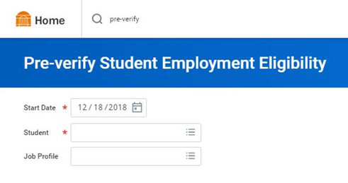
- Enter the name of the student you wish to hire in the Student field. In the Job Profile field, use the prompt icon to select By Job Family, then Student Workers, then identify an appropriate job profile within “Undergraduate/Graduate Wage” or “Work Study”, then click Submit
- Ensure that the student is eligible for the selected job profile by reviewing the result for “Eligible?” If yes, continue by clicking the button at the bottom of the page. For first time hires, this will display “Hire”; for students already employed, all current jobs will display and the button will read “Add Job.” If the student is not eligible due to not meeting the FWS eligibility rule, Workday will not allow you to proceed with hiring into a work study Job Profile.
Step 2: Hire or Add Job
- If the student is eligible, select Hire (will appear for students who are not currently employed at UVA) or Add Job (will appear for students who are currently employed at UVA).
- In Supervisory Organization, ensure a Job Management organization (will include “JM” in the name) is selected. If not, select the manager’s “JM” organization. If no “JM” organization is available, please contact your HR Business Partner to request that one be created.
- Click OK.
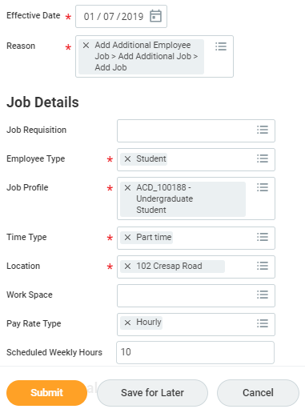
- Enter the Hire Date and Reason.
Federal law requires all new employees to complete the Form I-9, with part I completed by the employee by the first day of employment and part II completed by the employer within three days of hire. To ensure we are compliant with this requirement, always enter a student’s effective date as the actual first date of work, rather than an earlier date. Entering an earlier date makes it more likely that we appear out of compliance with this requirement, when in fact the student has not yet begun work. Once the hire is complete, the student will receive a Workday inbox task to complete part I. Until the I-9 is complete, they will not receive the Payment Elections task to add direct deposit information.
- Using the prompt icon, select the Employee Type “Student.”
- Using the prompt icon, select the Job Profile used in “Pre-Verify Student Employment Eligibility” Step 3. Refer to the Student Job Profile Selection Guide earlier in this document for assistance in selecting an appropriate job profile.
- Using the prompt icon, select the Time Type “Part Time.”
- Using the prompt icon, select the Location of work.
- Update the Scheduled Weekly Hours to the intended work hours per week; this should always be 20 hours/week or less. Do not change the Default Weekly Hours field.
- Optional: Click Additional Information to display additional fields.
- Optional: edit the Job Title to create a “working title” that will display on the student’s timecard, which is useful for students with multiple positions. And click Submit.
Step 3: Change Organization Assignments
This step will be immediately routed to the person who initiated “Hire Student” in Workday.
- After submitting the “Hire Student” task, you will see yourself as “Up Next.” Select the “Open” button to take action immediately, or go to your inbox and select the Assign Organizations task at any time.

- Review the information and click Submit.
Note: Changing the department here will route UVA Financial Approver tasks and payroll costing notifications for the hire to the assigned person(s) for the new department.

Step 4: Propose Compensation Hire
This step will be immediately routed to the person who initiated “Hire Student” in Workday.
- After submitting the “Assign Organizations” task, you will see yourself as “Up Next.” Select the “Open” button to take action immediately, or go to your inbox and select the Propose Compensation Hire task.
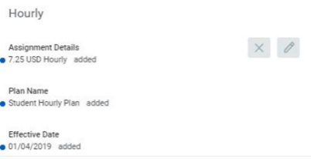
- Find the section labeled “Hourly” and enter the desired hourly rate by clicking the gray pencil icon and entering the rate in the “Amount” box. Note: rates above or below the range defined for the selected job profile will automatically route to Compensation for approval.
- Click Submit.

Step 5: Approval by Financial Approver
The assigned UVA Financial Approver for the selected Supervisory Organization will receive a task to approve the hire.
They can Approve, Send Back, or Deny the hire. If Send Back is selected, the initiator can revise and resubmit; if Deny is selected, the process is terminated.

Step 6: Onboarding Setup
- If Approve is selected by the Finance Approver:
• If an active employee who is receiving an additional job, the process will successfully complete;
• If a new hire, the initiator of the hire will receive the Onboarding Setup task and kickoff onboarding tasks for the student in Workday, including the Form I-9, tax and payment elections, and more;

Then
• The department is responsible for scheduling/maintaining the payroll costing allocation.

Period Activity Pay Student Hiring
Managers and local resources with the Student Hiring Support role can initiate student hires. Because all active students will already have a basic record in Workday, this requires minimal data entry and student eligibility can be verified in Workday prior to and after hire. Note: This job aid covers hiring students who receive period activity pay (a fixed sum distributed in equal payments across a specified period of time, like GTAs and GRAs) rather than an hourly rate; if hiring an hourly student, please refer to the appropriate job aid.
Please refer to policy PROV-001: Graduate Assistantships or contact the Office of Graduate and Postdoctoral Affairs if you have questions about whether your assignment should be classified as a GTA or GRA position.
Compensating a student on period-activity-pay for anything other than a GTA/GRA assignment would be rare and would require consultation with your HR Business Partner and may require approval from the Compensation Team.
If a student employee will have contact with patients or minors, they must undergo additional background screening prior to initiating the hire student process in Workday. Please contact the HR Solution Center at askhr@virginia.edu or 434-243-3344 to request this.
Step 1: Pre-Verify Student Employment Eligibility
If you already know the student you wish to hire, the “Hire Student” process can be initiated in a number of places in Workday. To make use of Workday’s student pre-employment eligibility check, you can:
- Use the Workday search bar to enter the student’s name to check if they’re in the system as a Contingent Worker, shown with a [C] behind the name.
- If found as a Contingent Worker, email AskHR@virginia.edu who will assist with the hire. Otherwise, go to Step 3.
- Use the Workday search bar to select the “Pre-verify Student Employment Eligibility” report.
- Enter the name of the student you wish to hire.
- In the Job Profile field, use the prompt icon to select “By Job Family,” then “Student Workers,” then identify an appropriate job profile within “Graduate Teaching/Research Assistants” or “Undergraduate/Graduate Wage.”
- Click Submit.
- Ensure that the student is eligible for the selected job profile by reviewing the result for “Eligible?” If yes, continue by clicking the button at the bottom of the page. For first time hires, this will display “Hire”; for students already employed, all current jobs will display and the button will read “Add Job.”
Step 2: Hire or Add Job
- If the student is eligible, select Hire (will appear for students who are not currently employed at UVA) or Add Job (will appear for students who are currently employed at UVA).
- In Supervisory Organization, ensure a Job Management organization (will include “JM” in the name) is selected. If not, select the manager’s “JM” organization. If no “JM” organization is available, please contact the HR Solution Center at 434-243-3344 or askhr@virginia.edu to request that one is created.
- Click OK.
- Enter the Hire Date and Reason.
Federal law requires all new employees to complete the Form I-9, with part I completed by the employee by the first day of employment and part II completed by the employer within three days of hire. To ensure we are compliant with this requirement, always enter a student’s effective date as the actual first date of work, rather than an earlier date. Entering an earlier date makes it more likely that we appear out of compliance with this requirement, when in fact the student has not yet begun work. Once the hire is complete, the student will receive a Workday inbox task to complete part I. Until the I-9 is complete, they will not receive the Payment Elections task to add direct deposit information.
- Using the prompt icon, select the Employee Type “Student.”
- Using the prompt icon, select the Job Profile used in “Pre-Verify Student Employment Eligibility” Step 3. Refer to the Student Job Profile Selection Guide earlier in this document for assistance in selecting an appropriate job profile.
- Using the prompt icon, select the Time Type “Part Time.”
- Using the prompt icon, select the Location of work.
- If Pay Rate Type defaults to “Salary,” please do not change the value to “Hourly” which may kick-off automated emails to enter hours for pay, which does not apply to Period Activity Pay-receiving student employees.
- Update the Scheduled Weekly Hours to the intended work hours per week; this should always be 20 hours/week or less. Student workers are allowed to work no more than 20 hours/week between all of their jobs. Do not update the Default Weekly Hours field.
- Optional: Click Additional Information to display additional fields.
- Optional: edit the Job Title to create a “working title” that will display on the student’s timecard, which is useful for students with multiple positions. Note: Students hired into a Job Profile within the “Graduate Teaching/Research Assistants” group or ACD_100502 – Student – Period Activity Pay will not submit a timecard.
- Click Submit.
Step 3: Change Organization Assignments
This step will be immediately routed to the person who initiated “Hire Student” in Workday.
- After submitting the “Hire Student” task, you will see yourself as “Up Next.” Select the “Open” button to take action immediately, or go to your inbox and select the Assign Organizations task at any time.
- Review the information and click Submit. Note: changing the department here will route UVA Financial Approver tasks for the hire to the assigned person for the new department.
Step 4: Approval by Financial Approver
The assigned UVA Financial Approver (or delegate) for the selected department will receive a task to approve the hire. Since Period Activity Pay has not been entered yet, no compensation information will appear on screen.
They can Approve, Send Back, or Deny the hire. If Send Back is selected, the initiator can revise and resubmit; if Deny is selected, the process is terminated.
Step 5: Period Activity Pay
If Approve is selected:
Period Activity Pay task will appear in the initiator’s inbox. This step will be immediately routed to the person who initiated “Hire Student” in Workday.
- Find the Period Activity Pay: (First Name, Last Name) task in your inbox, and click on it.
- Review the auto-filled Effective Date to ensure its correct.
- Enter the Academic Period to which this activity applies. The Period Activity Rate Matrix will auto-fill. Click OK.
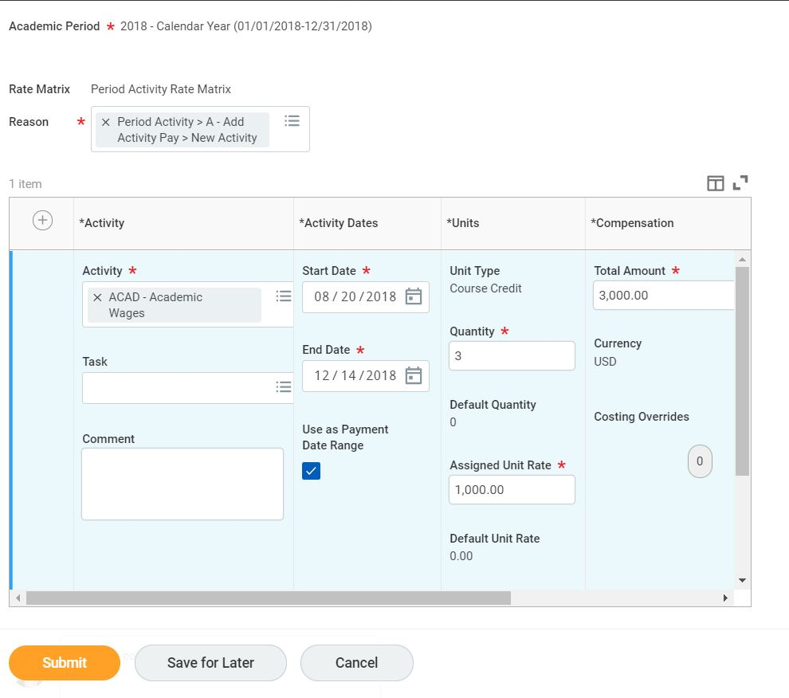
- Using the prompt icon, select a Reason, then scroll down to the Activity field. Use the prompt icon to select the Activity.
- Using the calendar icon, select the Start Date, End Date, Quantity of units, and an Assigned Unit Rate (i.e. amount paid per unit). The Total Amount will auto-calculate based on the quantity and rate. Optionally, enter a Task and/or Comment (e.g. Lit 301, Section 11).
- Click the + sign to add additional Period Activity Payments.
- Optional: Enter a comment.
- Click Submit.
Step 6: Onboarding Setup
If Approve is selected:
• If an active employee who is receiving an additional job, the process will successfully complete;
• If a new hire, the Onboarding Setup task will route to the person who initiated “Hire Student” and kickoff onboarding tasks for the student in Workday, including the Form I-9, tax and payment elections, and more;

Step 7: Approval by UVA Financial Approver
The assigned UVA Financial Approver for the selected department will receive a task to approve the hire.
They can Approve, Send Back, or Deny the hire. If Send Back is selected, the initiator can revise and resubmit; if Deny is selected, the process is terminated.

Graduated Student Working During the Summer
A graduated student may only work during the summer with an approved exception from the Provost’s Office. Once a student graduates if they plan to work in the summer up to the first day of classes per the Wage Authorization, you can hire the student following these steps:

Step 1: Hire Employee
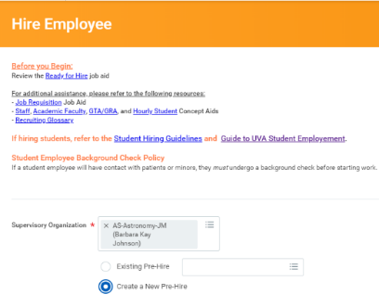
- Search for the ‘Hire Employee’ task.
- On the ‘Hire Employee’ task, select the appropriate JM Supervisory Organization.
- Select ‘Create a New Pre-Hire’ radio button.
- Click OK.
- On Legal Name Information tab, enter the student’s first and last name.
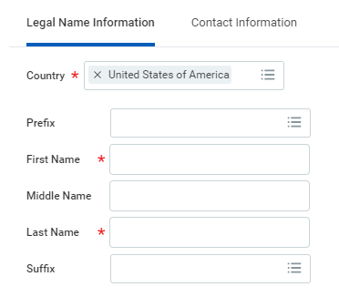
- Click on the ‘Contact Information’ tab.
- Enter at least once piece of contact information, preferably phone number, address, and email.
- Click OK.
- Enter the Hire Date and Reason. Ensure the Hire Date aligns with the student’s actual start date, even if in the past.
- Using the prompt icon, select the Employee Type “Student.”
- Using the prompt icon, select the Job Profile.
- Using the prompt icon, select the Time Type “Part Time.”
- Using the prompt icon, select the Location.
- Update the Scheduled Weekly Hours to the intended work hours per week; this should always be 20 hours/week or less. Do not update the Default Weekly Hours field.
- Optional: Click Additional Information to display additional fields.
- Optional: edit the Job Title to create a “working title” that will display on the student’s timecard, which is useful for students with multiple positions. And click Submit.
Step 2: Change Organization Assignments
This step will be immediately routed to the person who initiated “Hire Employee” in Workday.
- After submitting the “Hire Employee” task, you will see yourself as “Up Next.” Select the “Open” button to take action immediately, or go to your inbox and select the Assign Organizations task at any time.
- Review the information and click Submit.
Note: Changing the department here will route UVA Financial Approver tasks and LD notifications for the hire to the assigned person(s) for the new department.

Step 3: Propose Compensation Hire
This step will be immediately routed to the person who initiated “Hire Employee” in Workday.
- After submitting the “Assign Organizations” task, you will see yourself as “Up Next.” Select the “Open” button to take action immediately, or go to your inbox and select the Propose Compensation Hire task.
- Find the section labeled “Hourly” and enter the desired hourly rate by clicking the gray pencil icon and entering the rate in the “Amount” box. Note: rates above or below the range defined for the selected job profile will automatically route to Compensation for approval.
- Click Submit.

Step 4: Onboarding Setup
If Approve is selected by the Finance Approver:
• If an active employee who is receiving an additional job, the process will successfully complete;
• If a new hire, the initiator of the hire will receive the Onboarding Setup task and kickoff onboarding tasks for the student in Workday, including the Form I-9, tax and payment elections, and more;

Step 5: Approval by Financial Approver
The assigned UVA Financial Approver for the selected Supervisory Organization will receive a task to approve the hire.
They can Approve, Send Back, or Deny the hire. If Send Back is selected, the initiator can revise and resubmit; if Deny is selected, the process is terminated.

Hiring Students Employed with the Medical Center

If you are interested in hiring a student who is actively employed at the University Medical Center and plans to continue working in that position, in addition to your academic student assignment, please contact your HR Business Partner or email askhr@virginia.edu for assistance. A student occupying a Medical Center assignment will have a Job Profile title that begins with “MC_” and will have “UVA Medical Center” as their “Company”. Students employed in an academic job profile, one that starts with “ACD_”, in the School of Medicine (SOM,) are not Medical Center employees. Please note that the student is still limited to working 20 hours or less per week across all assignments and the student will not be eligible for FICA exemption on the academic assignment.

Create Job Requisition
If you are interested in posting to recruit the perfect student employee (including posting for a FWS student), you will use the “Create Job Requisition” task in Workday to begin the process. Once submitted, your request will be routed to the HR Talent Flexibility team that reviews job requisitions for students. Once it has been reviewed, the job posting will be automatically pushed to Handshake, the student recruiting platform managed by the UVA Career Center, for visibility. On the Handshake posting, students will be linked back to Workday to complete an application and go through the screening process. With Workday, all job posting creation and screening processes will now occur in one system for all employee types, with the added bonus of advertising for student positions on the popular Handshake platform!
Please keep in mind that only the supervisor and their delegate can create a job requisition in Workday. Individuals holding the Student Hiring Support role will not be able to create the job requisition on someone’s behalf.
For assistance with the “Create Job Requisition” task, we highly recommend using the Workday Digital Assist (WDA), the University’s primary tool for just-in-time guidance within Workday. If you do not have WDA. Visit the WDA page to download the browser extension.
**The advertising of student positions is not currently required.
If you are hiring a student into a federal work-study position and need a Handshake ID number, please contact askhr@virginia.edu.
For additional assistance, please reach out to the HR Talent Flexibility team by contacting askhr@virginia.edu or calling 434-243-3344.

Managing Multiple Jobs: Add Job, Switch Primary Job, End Additional Job, Terminate
If a student has only one job and it has ended, please use “Terminate Employee” to initiate the termination.
Use “Add Additional Job” to add a new job to a student worker. If the previous job has ended, use “Switch Primary Job” to make the new job primary, then use “End Additional Job” to end the previous job. This ensures there is no unnecessary break in employment.
For assistance with these tasks, please find the appropriate job aids on the Workday training site at https://hr.virginia.edu/workday-central/workday-training/workday-training-managers.

Additional Job Aids to Review
The Workday training site (http://workday.hr.virginia.edu) includes many more job aids that may be useful in managing and also assisting student employees. The following may be especially useful:

- Time Support Role
- Manager Timecard Approvals
- Enter Time for Employee
- Enter Time
- Payment Elections
- Contact Change
- Complete Form I-9
- Change Personal Information
- View and Print Payslip
- Manage Tax Withholdings
- Direct Deposit and Payment Elections
- Onboarding-HR-Student Worker
- Termination Manager
- End Additional Job
- Request Compensation Change
- Supervisory Org
- Outlook Notifications
- Inbox Filters and Archive
- Inbox and Tasks
- Inbox and Notifications
- Employee Self-Service
- Accessing Workday Mobile

Additional Resources
Most questions involving student employment can be answered by reviewing the policy and procedural documents linked to in the Student Employment Policies and Procedures section of this guide.

For additional assistance, please contact one of the following areas based on your specific need:

Entity | For? | Contact Information
HR Solution Center | - Student background checks  - Workday assistance  - Employee inquiries (pay, etc.) | askhr@virginia.edu  434-243-3344  http://hr.virginia.edu
Workday Training | - Self-paced Workday help | http://workday.hr.virginia.edu
Student Financial Services | - Federal Work Study | sfs@virginia.edu  434-982-6000  http://sfs.virginia.edu
Office of the Executive Vice President and Provost | - Graduate assistantship policy  - Wage authorization memo  - Student employment policy exceptions | http://provost.virginia.edu
UVA Career Center | - Student career resources  - Internships  - Handshake | careercenter@virginia.edu  434-924-8900  https://career.virginia.edu
International Students & Scholars Program | - Student employee visas (F-1/J-1) | issp@virginia.edu  434-982-3010  http://issp.virginia.edu

